1. Simple Calculator Program
Aim: To write a Python program to perform basic arithmetic operations using a simple calculator.
Algorithm:
- Start the program.
- Get two numbers and an operator from the user.
- Perform the operation using if-elif.
- Display the result.
- Stop the program.
Code:
a = float(input("Enter first number: "))
b = float(input("Enter second number: "))
op = input("Enter operator (+, -, *, /): ")
if op == '+':
print("Result =", a + b)
elif op == '-':
print("Result =", a - b)
elif op == '*':
print("Result =", a * b)
elif op == '/':
print("Result =", a / b)
else:
print("Invalid operator")
Output:
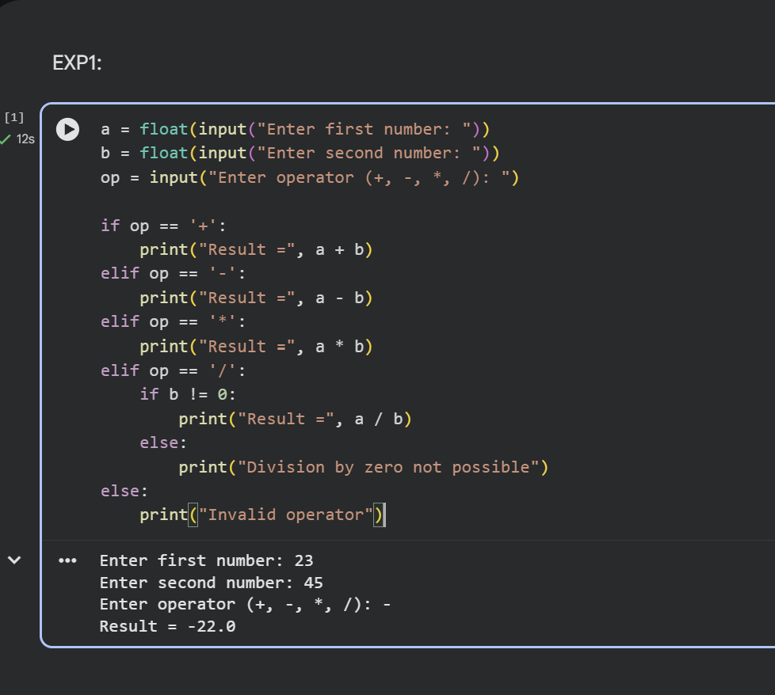

2. Add Two Matrices
Aim: To write a Python program to add two matrices.
Algorithm:
- Start the program.
- Initialize two matrices.
- Add corresponding elements using nested loops.
- Display the resultant matrix.
- Stop the program.
Code:
a = [[1, 2], [3, 4]]
b = [[5, 6], [7, 8]]
c = [[0, 0], [0, 0]]

for i in range(2):
for j in range(2):
c[i][j] = a[i][j] + b[i][j]
print("Sum of matrices:")
for row in c:
print(row)
Output:
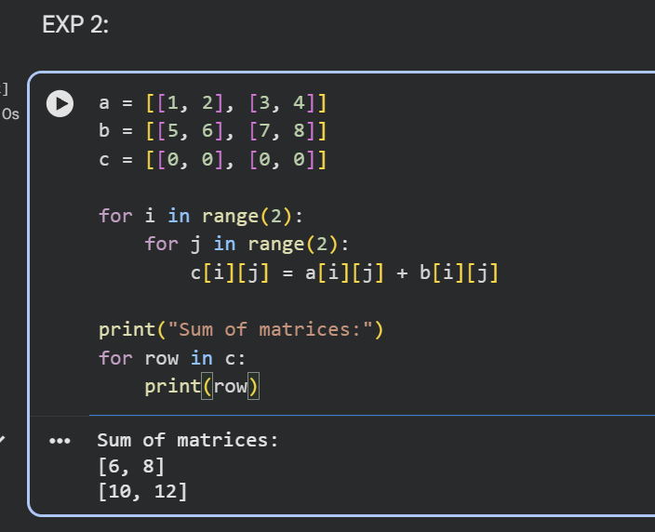

3. Transpose a Matrix
Aim: To write a Python program to find the transpose of a matrix.
Algorithm:
- Start the program.
- Initialize a matrix.
- Exchange the rows and columns.
- Display the transposed matrix.
- Stop the program.
Code:
a = [[1, 2, 3], [4, 5, 6]]

print("Transpose:")
for i in range(3):
for j in range(2):
print(a[j][i], end=" ")
print()
Output:

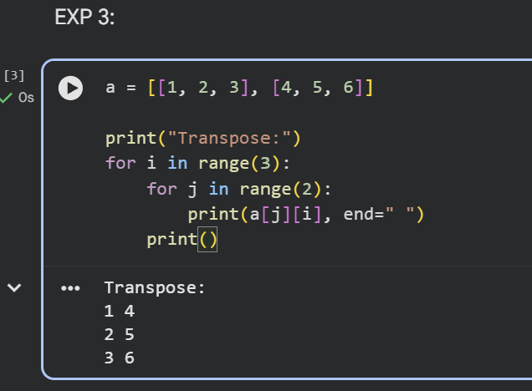

4. Sort a Sentence in Alphabetical Order
Aim: To write a Python program to sort the words in a sentence alphabetically.
Algorithm:
- Start the program.
- Get a sentence from the user.
- Split the sentence into words.
- Sort the words alphabetically.
- Display the sorted sentence.
- Stop the program.
Code:
s = input("Enter a sentence: ")
words = s.split()
words.sort()
print("Sorted sentence:", " ".join(words))
Output:
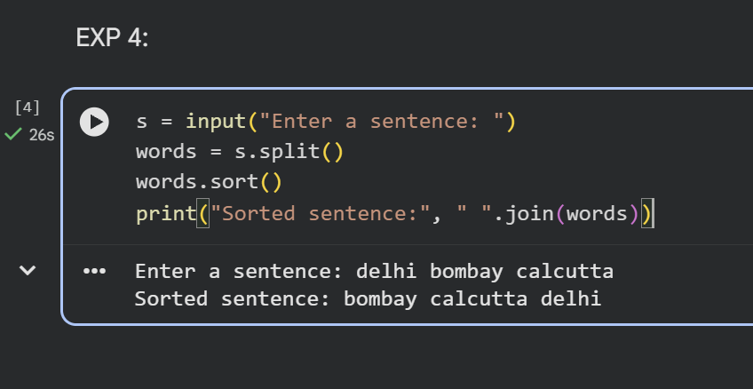

5. Implement List Operations
Aim: To write a Python program to perform list operations such as nested list, length, concatenation, membership, iteration, indexing and slicing.
Algorithm:
- Start the program.
- Create a list of elements.
- Perform the required list operations.
- Display the results.
- Stop the program.
Code:
a = [10, 20, 30, 40]
print("List:", a)
print("Nested List:", [a, [50, 60]])
print("Length:", len(a))
print("Concatenation:", a + [50, 60])
print("Membership:", 20 in a)
print("Iteration:")
for i in a:
print(i)
print("Indexing:", a[1])
print("Slicing:", a[1:3])
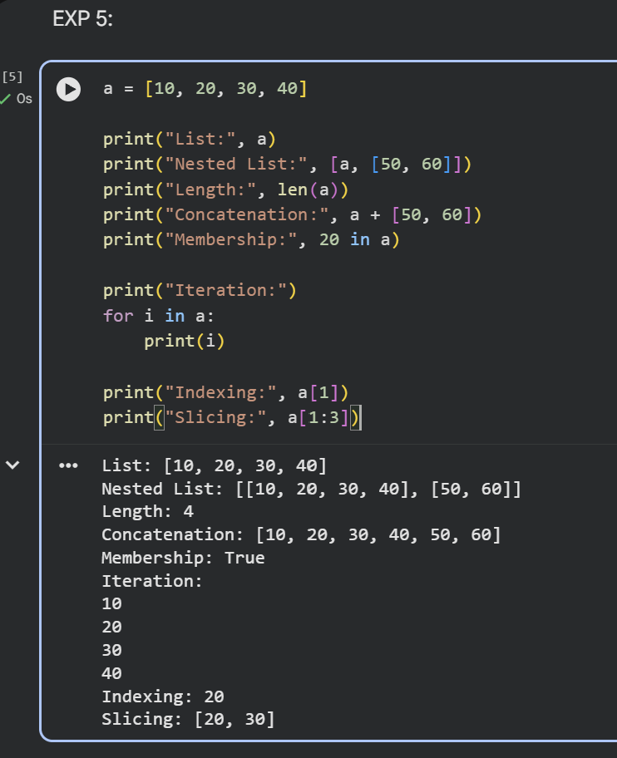
Output:

6. Python Program to Implement List Methods (Add, Append, Extend and Delete)
Aim: To write a Python program to demonstrate list methods such as adding, appending, extending and deleting elements.
Algorithm:
- Create a list.
- Add and append elements to the list.
- Extend the list with another list.
- Delete an element.
- Display the results.
Code:
a = [10, 20, 30]
print("Original List:", a)
a.insert(1, 15)
print("Add:", a)
a.append(40)
print("Append:", a)
a.extend([50, 60])
print("Extend:", a)
del a[0]
print("Delete:", a)
Output:

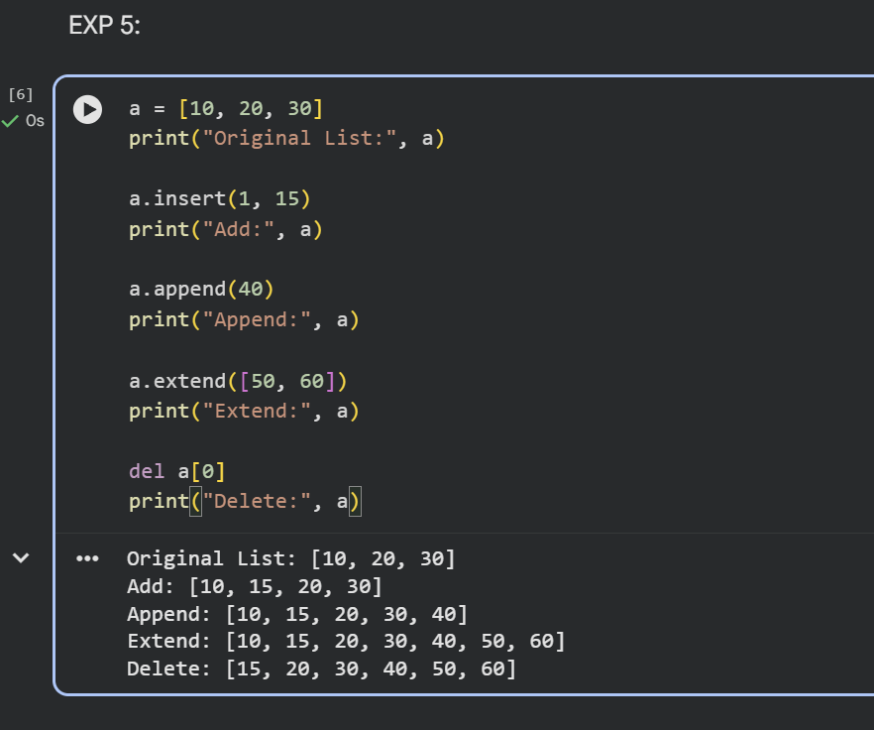

7. Python Program to Illustrate Different Set Operations
Aim: To write a Python program to perform set operations such as union, intersection, difference and symmetric difference.
Algorithm:
- Create two sets.
- Perform union and intersection.
- Perform difference and symmetric difference.
- Display the results.
Code:
a = {1, 2, 3, 4}
b = {3, 4, 5, 6}
print("Union:", a | b)
print("Intersection:", a & b)
print("Difference:", a - b)
print("Symmetric Difference:", a ^ b)
Output:

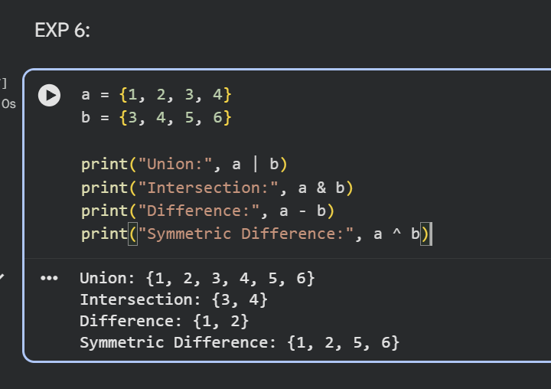

8. Python Program to Generate Calendar for the Given Month and Year
Aim: To write a Python program to display the calendar for a given month and year.
Algorithm:
- Import the calendar module.
- Get the month and year from the user.
- Generate the calendar.
- Display the calendar.
Code:
import calendar
year = int(input("Enter year: "))
month = int(input("Enter month: "))
print(calendar.month(year, month))
Output:

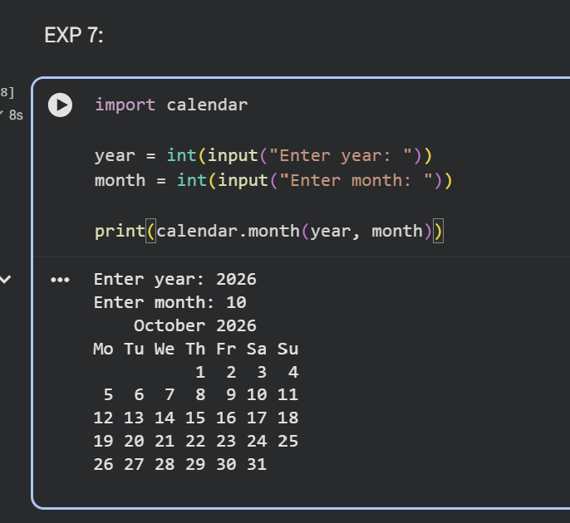

9. Python Program to Remove Punctuations from a Given String
Aim: To write a Python program to remove punctuation marks from a given string.
Algorithm:
- Get a string from the user.
- Create a string containing punctuation marks.
- Check each character.
- Remove punctuation marks.
- Display the result.
Code:
import string
s = input("Enter a string: ")
result = ""
for ch in s:
if ch not in string.punctuation:
result += ch
print("String without punctuation:", result)
Output:
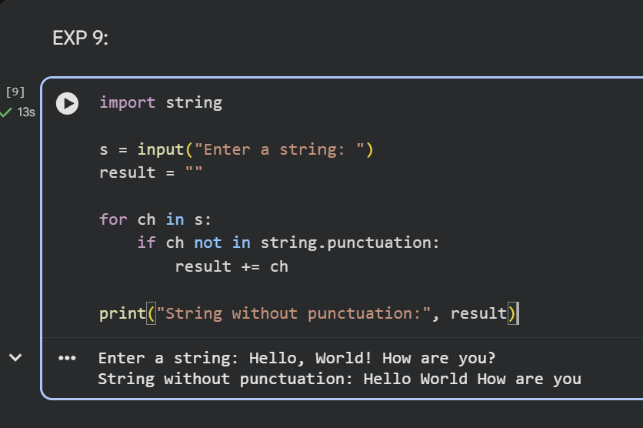

10. Python Program to Solve the 8-Puzzle Problem
Aim: To write a Python program to solve the 8-puzzle problem using the A* search algorithm.
Algorithm:
- Define the initial and goal states.
- Calculate the Manhattan distance heuristic.
- Select the state with the lowest cost.
- Generate possible moves of the blank tile.
- Repeat until the goal state is reached.
- Display the solution steps.
Code:
from heapq import heappush, heappop
start = (1, 2, 3, 4, 0, 6, 7, 5, 8)
goal = (1, 2, 3, 4, 5, 6, 7, 8, 0)
def h(s):
d = 0
for i in range(9):
if s[i] != 0:
g = s[i] - 1
d += abs(i // 3 - g // 3)
d += abs(i % 3 - g % 3)
return d
q = [(h(start), 0, start, [])]
seen = set()
while q:
f, cost, s, path = heappop(q)
if s in seen:
continue
seen.add(s)
if s == goal:
for state in path + [s]:
print(state[:3])
print(state[3:6])
print(state[6:])
print()
break
z = s.index(0)
r, c = divmod(z, 3)
for dr, dc in [(1, 0), (-1, 0), (0, 1), (0, -1)]:
nr, nc = r + dr, c + dc
if 0 <= nr < 3 and 0 <= nc < 3:
nz = nr * 3 + nc
t = list(s)
t[z], t[nz] = t[nz], t[z]
t = tuple(t)
if t not in seen:
heappush(q, (cost + 1 + h(t),
cost + 1, t, path + [s]))
Output:
